🚀 GitHub Copilot – Foundations & Architecture

🔹 What is GitHub Copilot?
GitHub Copilot is an AI-powered coding assistant developed by GitHub in partnership with OpenAI.
👉 It helps developers:
- Write code faster
- Generate functions automatically
- Suggest improvements
- Debug issues
- Explain code
💡 Think of it as a smart coding partner inside your IDE.

🎯 Why Use GitHub Copilot?

Key Benefits
- ⏱️ Saves development time
- 🧠 Reduces cognitive load
- 📚 Helps learn new frameworks/languages
- 🛠️ Improves productivity
- 🔍 Assists in debugging and testing

Real Example
👉 Instead of writing:
function calculateTotal(cartItems) {
let total = 0;
for (let item of cartItems) {
total += item.price * item.quantity;
}
return total;
}
👉 You just type:
// calculate total price of cart items
💥 Copilot generates the full function.

🧠 Architecture & Flow (Very Important)

🔹 How Copilot Works Internally
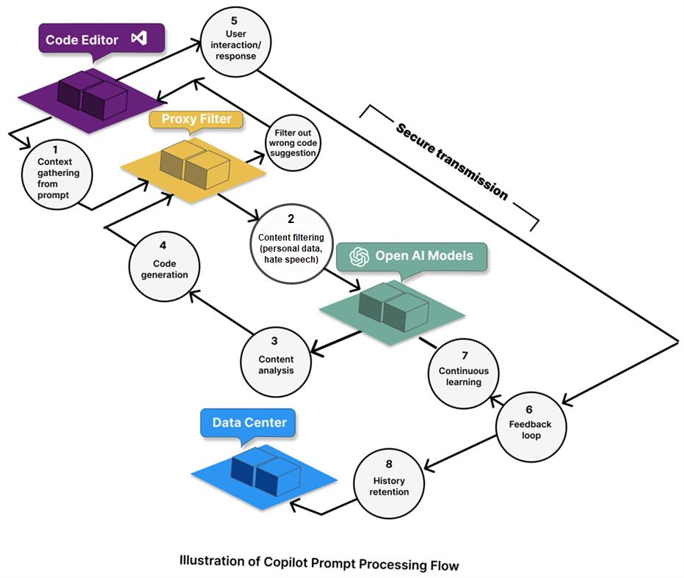


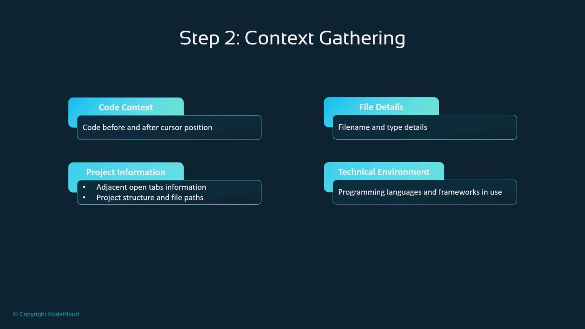
9

Step-by-Step Flow

1️⃣ Context Gathering
- Reads:
  - Current file
  - Open tabs
  - Comments
  - Function names
- Builds a context window
👉 Example:
// create login validation function
➡️ Copilot understands:
- language (JS)
- intent (login validation)

2️⃣ Pre-Model Filters
- Removes sensitive data
- Ensures compliance
- Sanitizes prompt

3️⃣ Proxy Service (Security Layer)
- Acts as a middle layer
- Your code does NOT directly go to AI model
- Handles:
  - authentication
  - encryption
  - routing

4️⃣ AI Model Processing
- Uses LLMs (like GPT models)
- Generates:
  - code
  - suggestions
  - explanations

5️⃣ Post-Model Filters
- Filters:
  - insecure code
  - harmful patterns
  - policy violations

6️⃣ Output to IDE
- Suggestions appear as:
  - inline code
  - chat responses
  - edits

⚙️ Installation & Setup

🔹 Step-by-Step Setup

1️⃣ Install IDE
- Use Visual Studio Code

2️⃣ Install Copilot Extension
- Open Extensions (Ctrl + Shift + X)
- Search: GitHub Copilot
- Install

3️⃣ Sign In
- Login with GitHub account

4️⃣ Enable Features
- Copilot Chat
- Inline Suggestions

5️⃣ Test It
// create API to fetch users
➡️ You’ll see suggestions instantly.

🔐 Code Privacy & Safety

🔹 Important Concept
👉 Your code is NOT used for training models

How it works:
- Code passes through:
  - Proxy service
  - Filters
- No permanent storage
- No training reuse

🔹 Security Highlights
- 🔒 Encryption in transit
- 🚫 No direct model access
- 🧹 Sensitive data filtering

⚠️ What You Should Still Do
- Never paste:
  - API keys
  - passwords
  - secrets

🧾 Output Types Overview

🔹 1. Inline Completions
👉 Appears as grey text
// sort array in ascending order
➡️ Auto suggestion

🔹 2. Chat Responses
- Ask questions
- Get explanations
👉 Example:
"Explain this function"

🔹 3. Agent Actions
- Auto:
  - fix bugs
  - refactor code
  - generate files

🔹 4. Code Edits
- Modify selected code
👉 Example:
"Convert to async/await"

🔹 5. Terminal Commands
👉 Suggests commands like:
npm install axios

⚖️ Differences (Very Important)
Feature | Inline Suggestions | Copilot Chat | Agent Mode
Trigger | Typing | Asking question | Task-based
Output | Code | Explanation + Code | Full automation
Use Case | Quick coding | Learning/debugging | Complex tasks
Control | Low | Medium | High

✅ Do’s & ❌ Don’ts

✅ Do’s
- Write clear comments
- Use meaningful variable names
- Review generated code
- Use for repetitive tasks
- Combine with your logic

❌ Don’ts
- ❌ Don’t blindly trust output
- ❌ Don’t paste sensitive data
- ❌ Don’t use without understanding
- ❌ Don’t rely fully (use as assistant, not replacement)

🌍 Real-World Use Case (E-Commerce App)

Scenario:
You are building a React E-Commerce Application

Tasks with Copilot:

🛒 1. Product Listing
// display product list with image and price
➡️ Copilot generates UI code

🔍 2. Search Feature
// filter products based on search input
➡️ Generates filtering logic

🧾 3. Cart Calculation
// calculate total price
➡️ Auto-generates function

🧪 4. Test Cases
// write jest test for cart calculation
➡️ Generates test code

🐛 5. Debugging
👉 Ask:
"Why is quantity not updating?"
➡️ Copilot suggests fix

🧠 Best Practice Workflow
👉 Real Developer Flow:
- Write requirement (comment)
- Accept suggestion
- Modify logic
- Test code
- Refactor using chat
- Generate tests

📌 Final Summary
- Copilot = AI Pair Programmer
- Works using:
  - Context → Filters → Proxy → AI → Output
- Helps in:
  - Coding
  - Debugging
  - Learning
- Always:
  - Review + validate

